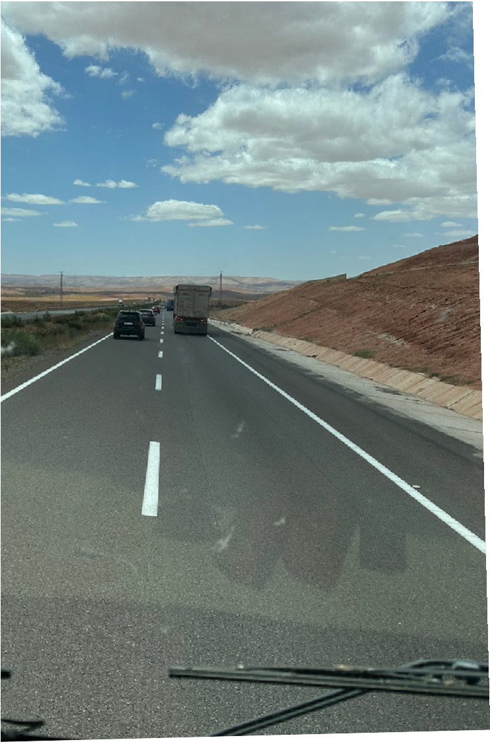
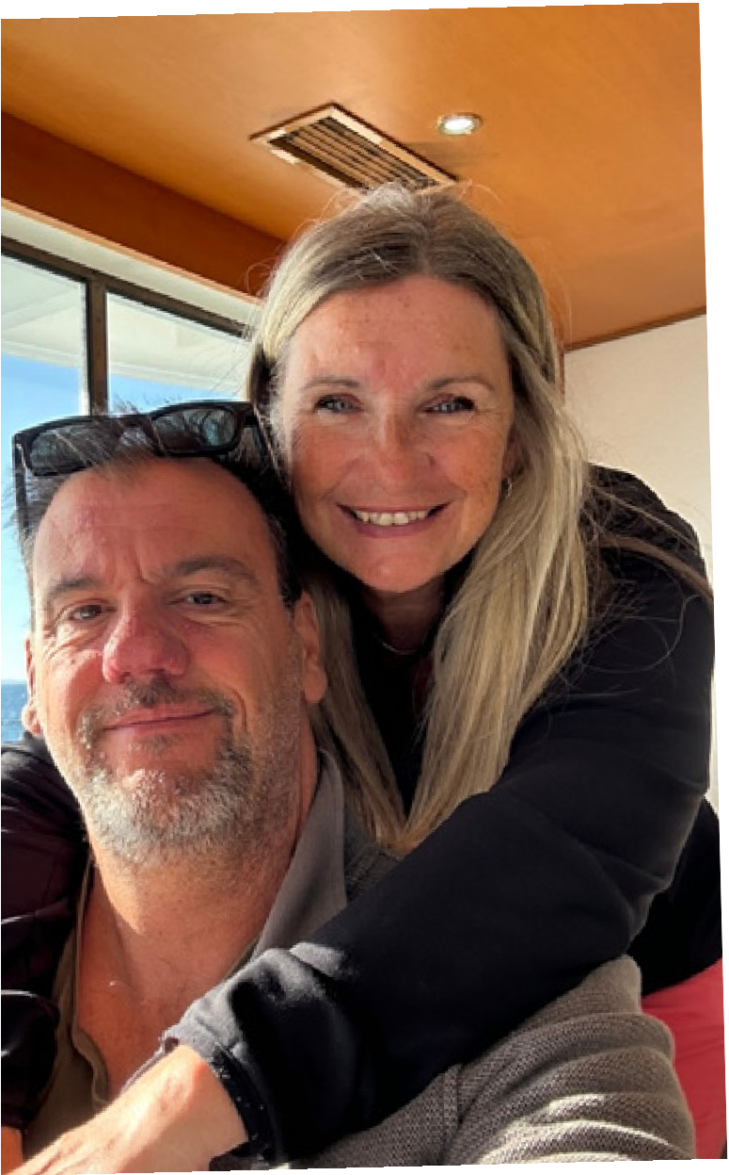
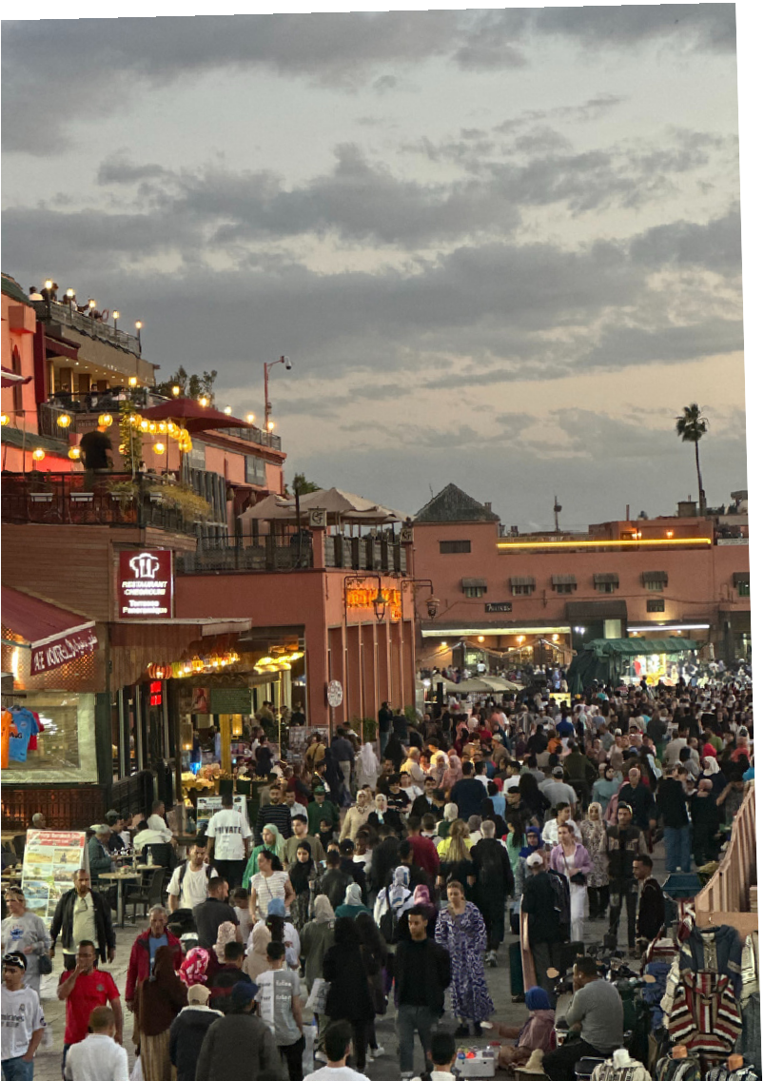

The Bebbs Beat
We’re The Bebbs — a husband and wife duo from the UK who decided to leave behind the conventional lifestyle and live life on our own terms. After years of running our own businesses (a shop and a café), we realised we wanted something more. In 2023, we moved out of our home, bought our first American 5th wheel (Nellie), and began a brand new chapter on the road.

Now, we live full-time in our RV, Betty, travelling across the UK, Europe, and beyond. With Scott’s shop still running back home, we’ve been able to fund our travels while sharing the journey on our YouTube channel, blog, and social media.

We share the real side of RV life — the learning curves, the freedom, the challenges, and the unexpected joys — always with honesty and a sense of humour. Our goal is to inspire others to explore a life with fewer rules, more freedom, and a lot more adventure.

Our audience is primarily based in the UK, with a growing number of viewers across Europe, the US, and Australia. They are motorhome owners, van lifers, caravanners, and travel lovers aged mainly 35–65+ who appreciate practical tips, down-to-earth storytelling, and an alternative way of life.

We’re not chasing viral moments — we’re creating real connections with people who return week after week for updates, inspiration, and honest advice from the road.
591
357
4523
The Bebbs Beat is a growing travel and motorhome lifestyle brand with an engaged and loyal audience that values honesty, real-life experiences, and off-grid adventure.
We may be a small channel, but we’re building a strong and trusted community of like-minded people who are curious about full-time RV life, downsizing and travelling differently.
YouTube
Instagram
Facebook
We love working with brands and businesses that align with travel, motorhome life, sustainability, and simple, off-grid living. We only promote things we genuinely use or believe in — and our audience trusts us for that.

Here’s how we can work together:
- YouTube Integrations & Mentions
- Sponsored Blog or Social Media Posts
- Affiliate Partnerships
- Product Reviews or Features
- Event or Travel Coverage
- Giveaways or Brand Ambassadorships

We’re always open to ideas — if it’s a natural fit for our lifestyle and our audience, we’d love to chat.

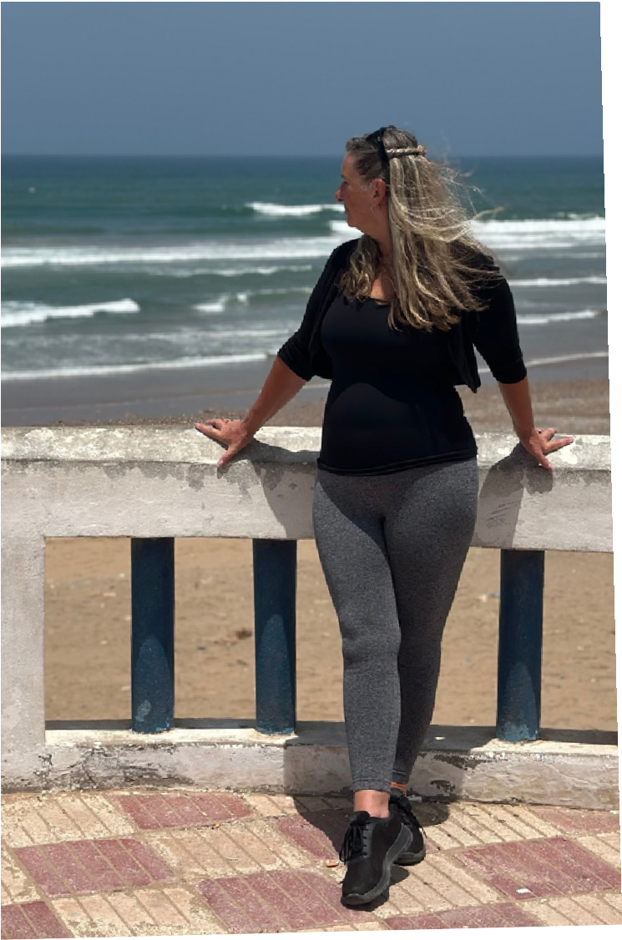
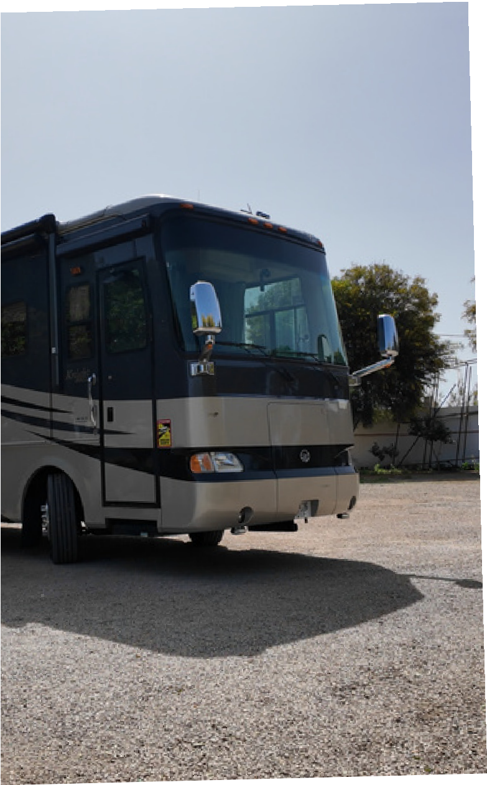


We’re not influencers chasing trends — we’re real people living a lifestyle that many dream about but aren’t sure how to begin. That’s what makes our content relatable and trustworthy. Our audience follows us because we’re honest, practical, and living proof that it’s possible to step away from the norm and build a life on the road.
PREVIOUS WORK
We’ve proudly partnered with brands such as AllPowers, Haloview, FitVille, and Rosetta Stone — creating authentic, relatable content that showcases products we genuinely use and trust in our full-time RV lifestyle.

Our YouTube channel, The Bebbs Beat, has grown steadily since launch and now has over 1,600 subscribers. Our audience follows us for honest insights, real-world travel tips, and down-to-earth storytelling, and we regularly receive messages from fellow motorhomers seeking advice on everything from gear to travel routes.
We’re selective about the brands we work with, focusing on long-term, meaningful collaborations that fit naturally into our content and provide real value to our community.
WHY WORK WITH US

As full-time RV travellers, we bring real-world experience, not just polished pictures. Whether we’re wild camping in Spain, navigating Moroccan roads, or fixing things on the go, we show the real side of travel — and that’s what our community connects with.

Working with us means working with a brand that values honesty, meaningful storytelling, and long-term trust over quick clicks. If your product or service fits naturally into this lifestyle, we’d love to bring it to life in a way that genuinely resonates.
Email – thebebbsbeat@gmail.com
Website – www.thebebbsbeat.com
YouTube – The Bebbs Beat
Instagram - @thebebbsbeat
Facebook – The Bebbs Beat
Interested in working together? We’d love to hear from you.
LETS CONNECT
We’re open to collaborations, sponsorships, affiliate opportunities, and
partnerships that make sense for our lifestyle and audience. Drop us a message and let’s chat!

